Transferring a Bench
You can use Touch Point to transfer a bench elevation via a common hard point when you use Depth and Slope mode without a laser catcher. Touch point is only available after you bench the system and requires a common feature, such as a rock, that you can easily access from both your original working position and your new working position.
Note: If you do not have a heading sensor you cannot rotate the cab when you move from one working position to another and must reach the Touch Point in the digging orientation of the excavator front linkage.
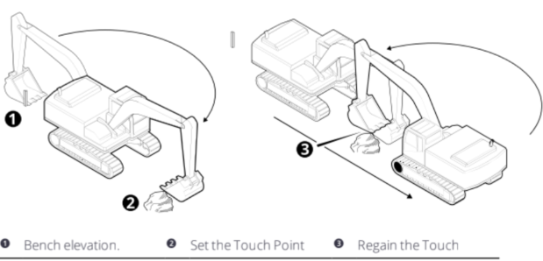
1.Position the attachment focus on the Touch Point (common point).
2. Tap the Touch Point icon in the Text Ribbon.
3. Move the machine to your new working position and place the attachment focus on the same Touch Point (common point).
4. Tap Regain. The reference elevation is transferred.
5. Tap Done. You can now work the surface relative to the original bench.
Note- If you do not have a heading sensor you cannot rotate the cab when you move from one working position to another and must reach the Touch Point in the digging orientation of the excavator front linkage.
